BUFFET BREAKFAST MENU

Adults £19.50
Children under 16 £12.50

. . . . .

English Breakfast Tea
Filter Coffee
Apple Juice
Orange Juice

. . . . .

Selection of Freshly Baked Pastries
Selection of Cereals
Fresh Fruit
Croissants
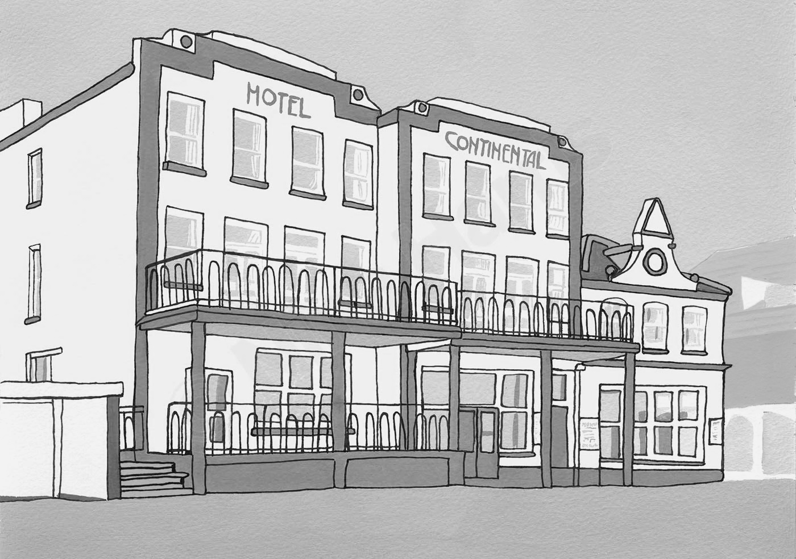
Toast & Tiptree Preserves

. . . . .

Farmhouse Sausage
Vegan Sausage
Streaky Bacon
Sautéed Mushrooms
Peeled Plum Tomatoes
Hash Browns
Baked Beans

. . . . .

MONDAY-FRIDAY: 7:00AM-10:00AM
SATURDAY & SUNDAY: 7:30AM-10:30AM

If you have any allergies please speak to a member of the team who can advise you accordingly in order to minimise the risk of cross contamination. Card Only.
A discretionary 10% service charge.

